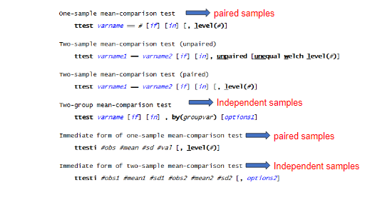

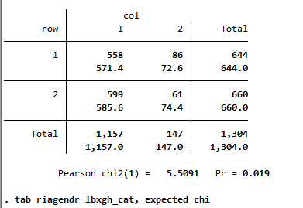

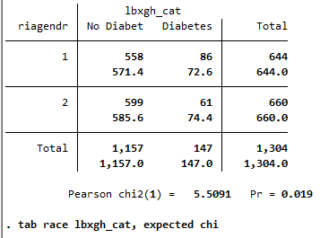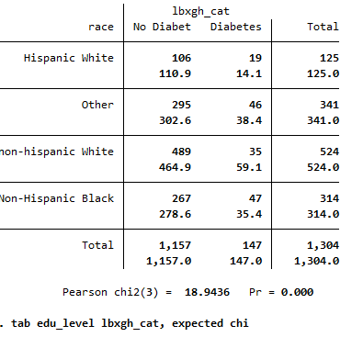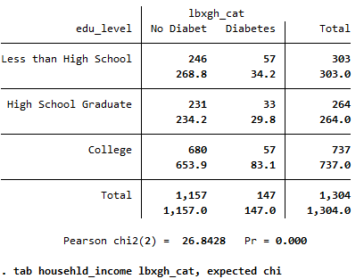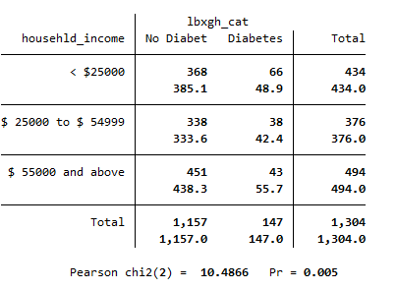

2. Ho = mean urine albumin levels for normal = mean urine albumin levels for prediabetic = urine albumin level for diabetic

Ha = mean of at least one is different

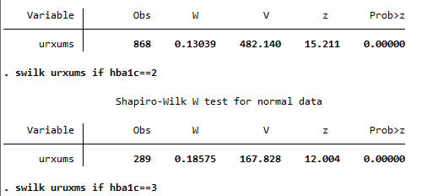

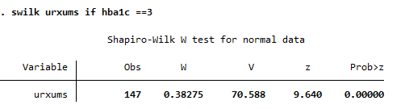

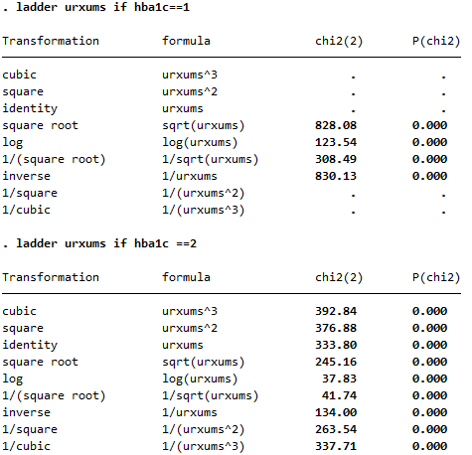

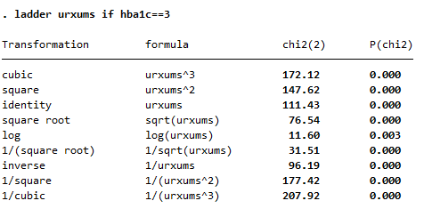

No transformation works

Using kwallis test for multiple variables

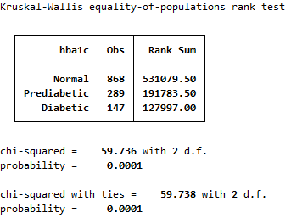

P= 0.0001 < 0.05 reject null and say that the urine albumin levels differ by hba1c

2b Ho = serum creatinine levels are the same across all three hba1c levels, Ha= serum creatinine levels are different for at least one group

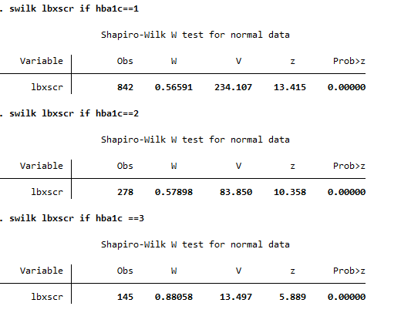

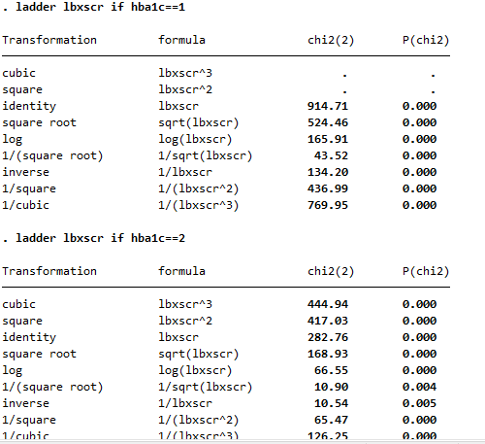

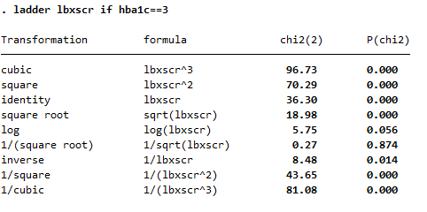

**P value = 0.0001 which is** less than 0.05, we reject the null hypothesis and conclude that at least one of the groups are different

Regression: Independence, normality, linearity, variability

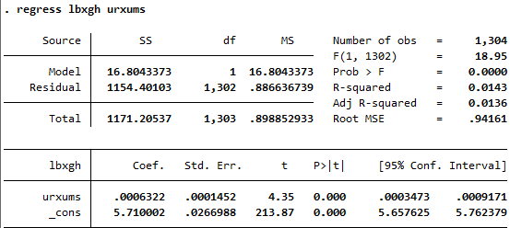







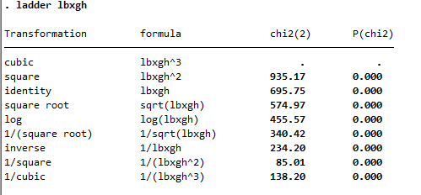

For hemoglobin and serum creatinine

